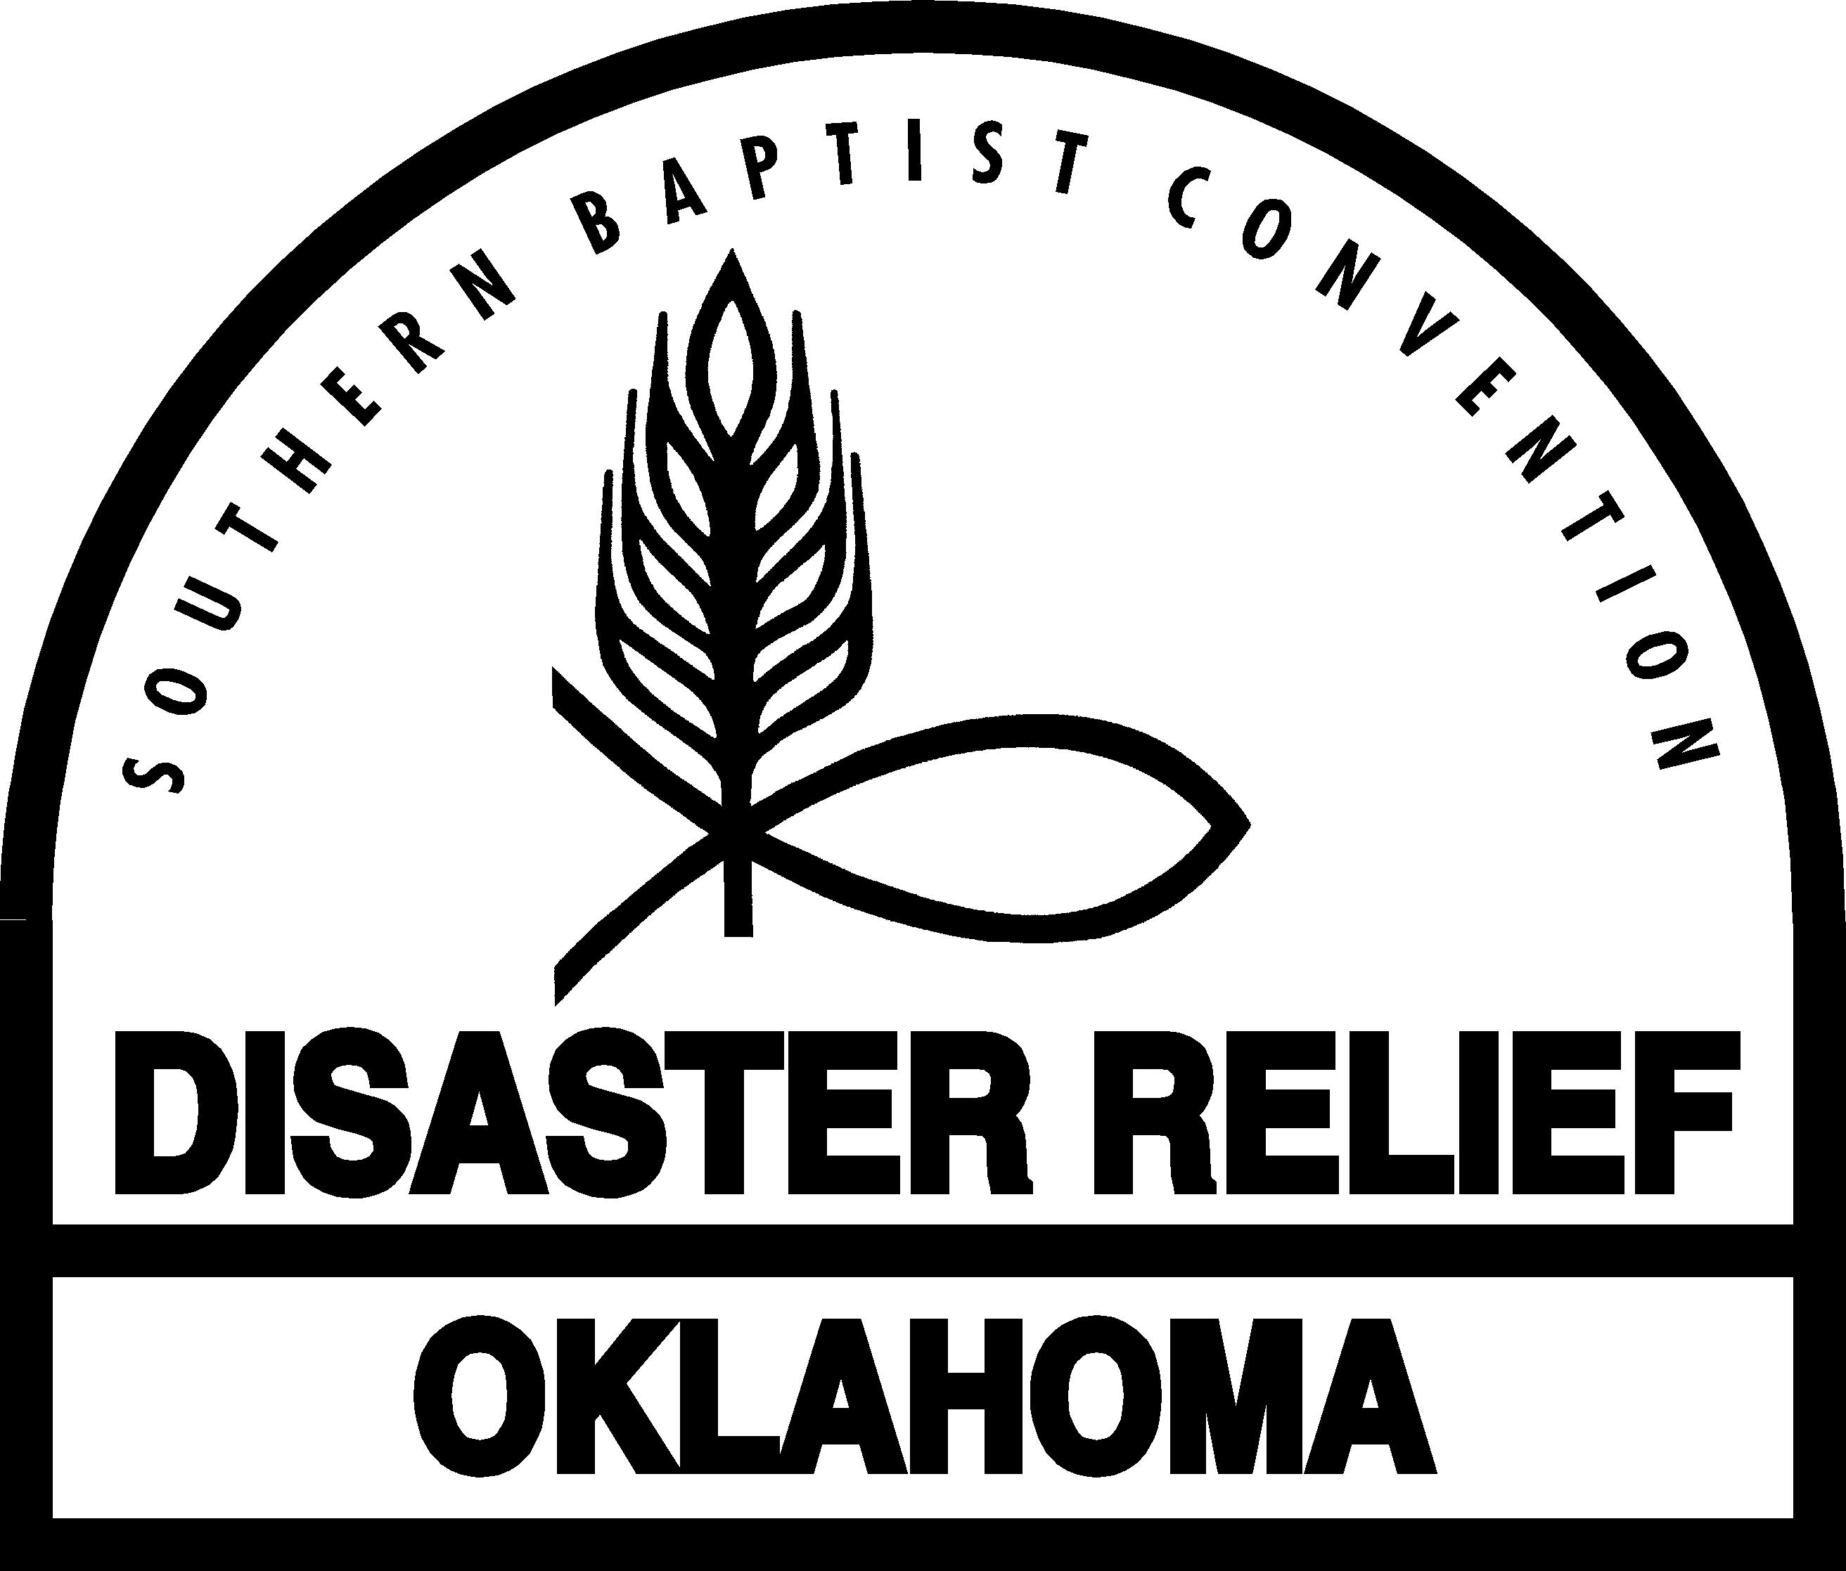
Safety Checklist for Disaster Relief Unit Leaders

◻ Accept responsibility for your Team’s safety Provide the leadership and management needed for the safety of your Team and the safety of the people you are helping.

◻ Consider safety when filling positions Fill the positions on your Team with persons who have demonstrated a commitment to safety.

◻ Prepare your Team to work safely Hold practice exercises with your Team to develop
the teamwork, communication, and job skills necessary for safety.

◻ Be able to get medical help quickly Before starting work in a new location find out how your Team will obtain emergency medical assistance if it is needed.

◻ Respect health and physical limitations Ask Team members to tell you about health or physical limitations that could compromise their own safety or the Team’s safety. Consider Team members’ limitations when assigning and scheduling work.

◻ Safeguard against worksite hazards Inspect each new worksite or work situation for hazards. Build safety into every aspect and step of the job. Rule out any work that cannot be done safely. Plan safety zones and escape routes, and make them known to your Team.

◻ Rely on standard procedures and equipment For safety, use the standard Disaster Relief operating procedures and equipment. Use the Disaster Relief Manuals. Avoid short-cuts and spur-of-the-moment changes. Before changing to unfamiliar procedures or equipment evaluate the safety implications and know the necessary safety precautions.

◻ Communicate effectively Give clear, timely safety instructions and check for understanding. Be able to communicate with your Team at all times; keep communication lines open between you and your Team, and among Team members.

◻ Be vigilant Watch what is happening at the worksite at all times. Stay alert; workplaces are ever-changing. Don’t be distracted; incidents can happen quickly. If you see an unsafe act or unsafe condition, act decisively. Always put safety first above other considerations.

◻ Reinforce safety Hold safety meetings for your Team at the beginning and end of the day. Discuss errors that lead to accidents and how to avoid them. Review health precautions. Critique completed work for safety lessons learned. Encourage “safety-awareness” at all times – while traveling to or from, and while at the disaster site.

◻ Review incidents Review every accident, injury, illness or incident as soon as possible after it occurs. Take any corrective action needed. Complete an Incident Report. Report any suspicious activity, threat or other like act to the Incident Commander.

November 1, 2009

